Lab 1

COMP6035: Computer Security Principles



**Your Name**

Student #: R00201303

Date: 16.11.2021

Group: COMP1D-y

# PART 1

# TASK 1:

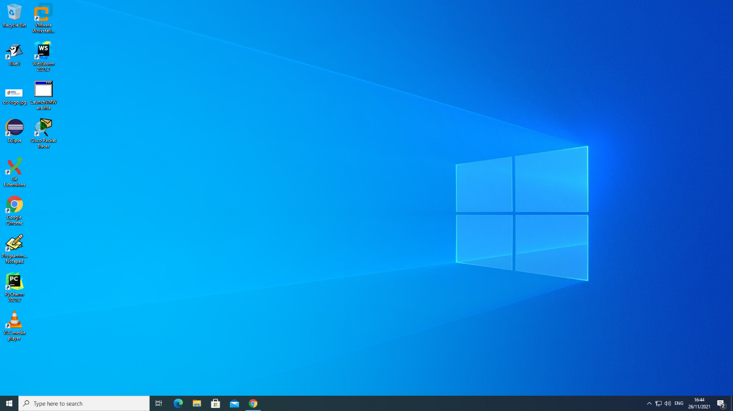

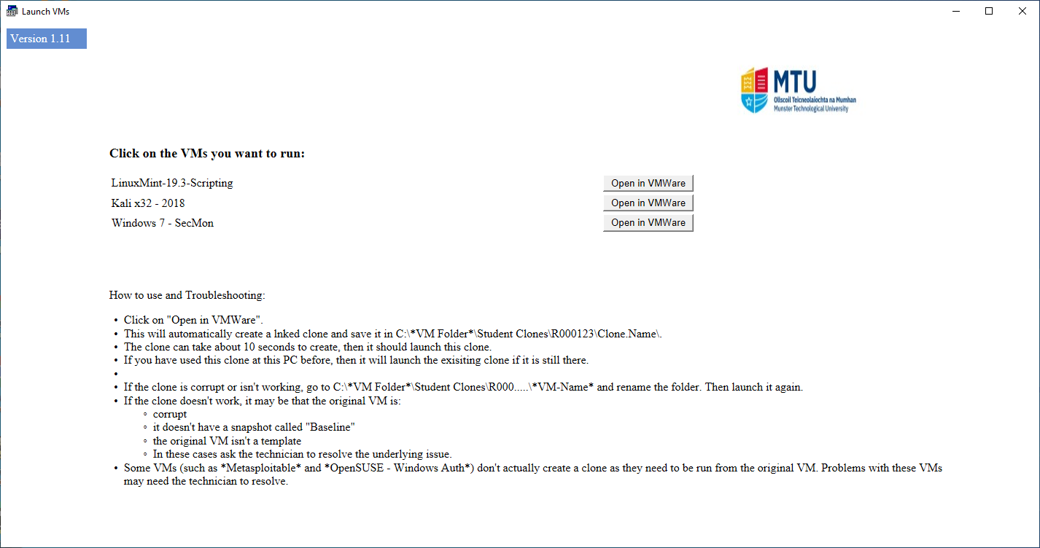

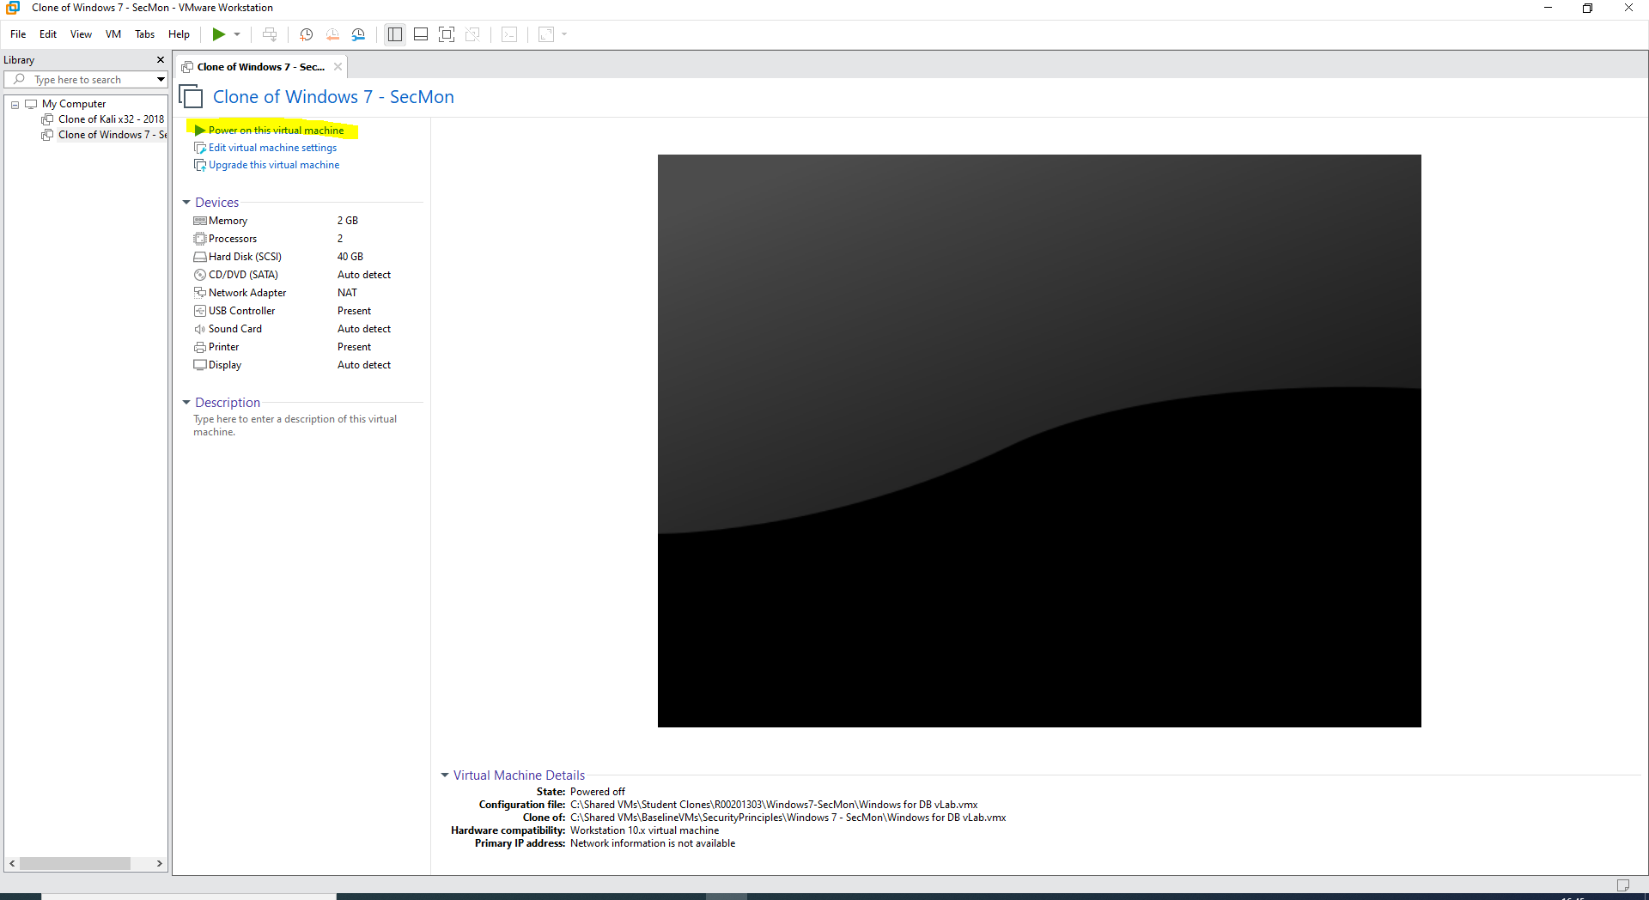

Screenshot(s) of VM:

# TASK 2:

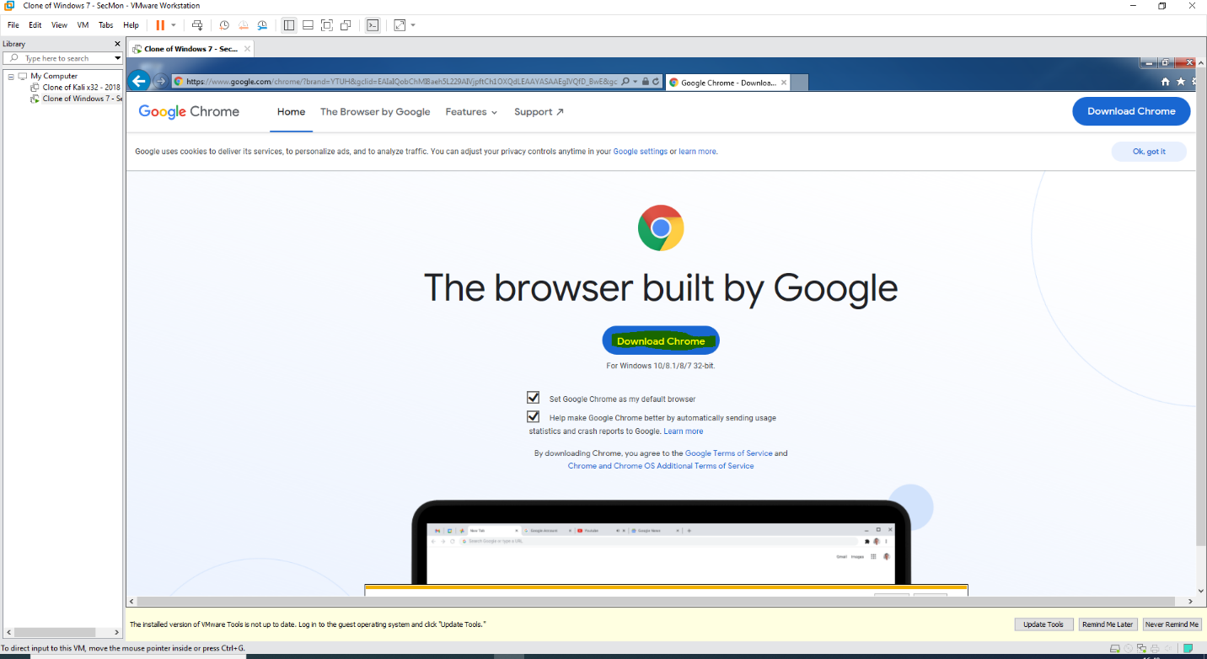

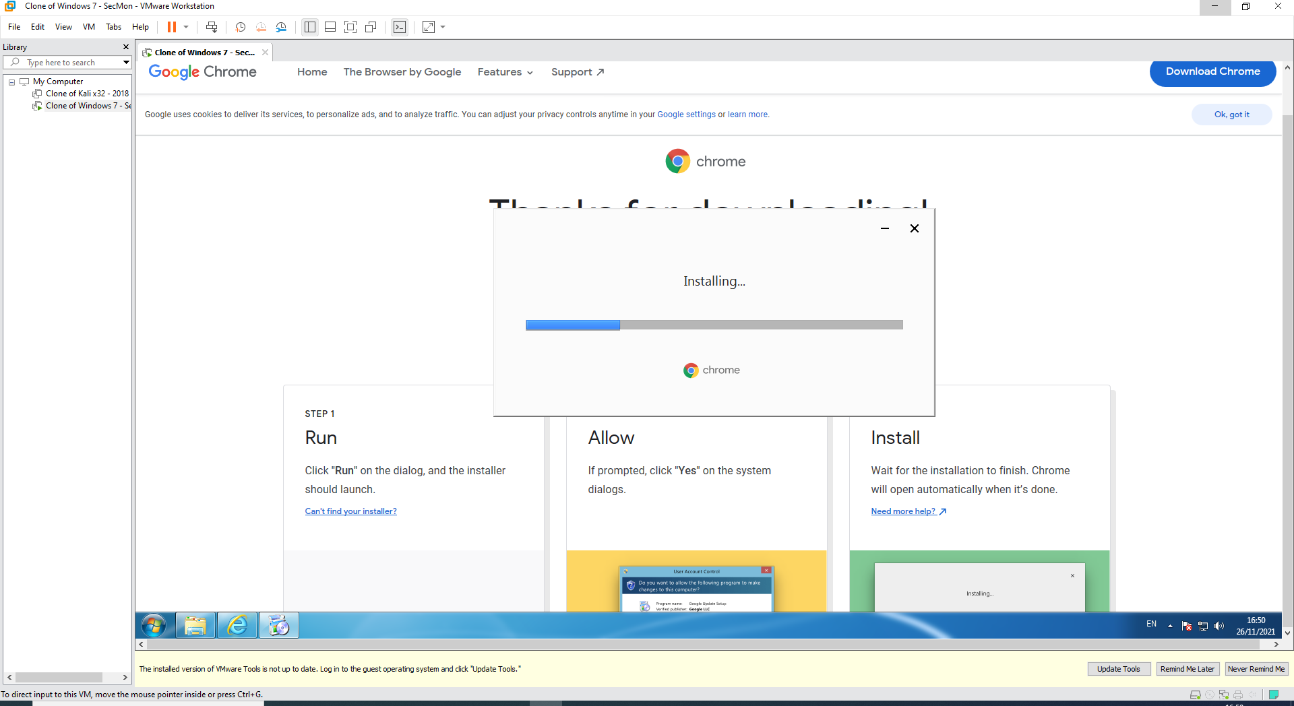

Screenshot(s) of Google Chrome & observations:

Google chrome was downloaded to perform the rest of tasks the internet-related tasks.

# TASK 3:

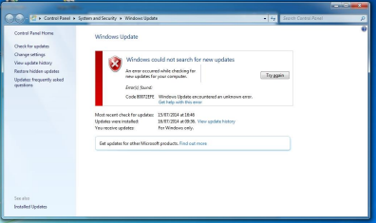

Screenshot(s) of OS updates & observations:

As shown above, the windows could not search for new updates

# TASK 4:

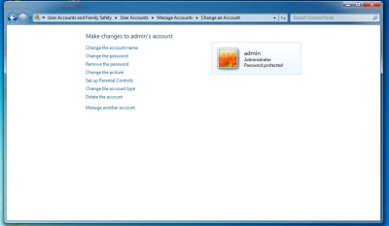

Screenshot(s) of admin login & password & observations:

Admin login was successful, and changes could be made to the account

# TASK 5:

# 

Screenshot(s) of user login (john) & password & observations:

Admin login with the given login details was also successful.

# TASK 6:

Screenshot(s) of 32-bit MS Security Essentials & observations:

32-bit version microsoft security essential was installed and the pc was being protected

# TASK 7:

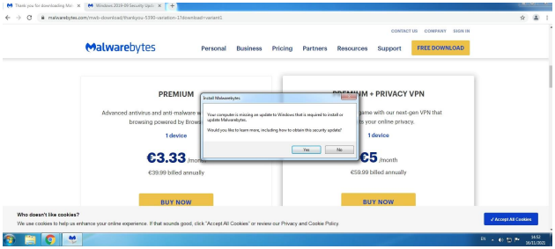

Screenshot(s) of Malwarebytes & observations:

Malwarebytes installed and tested

# TASK 8:

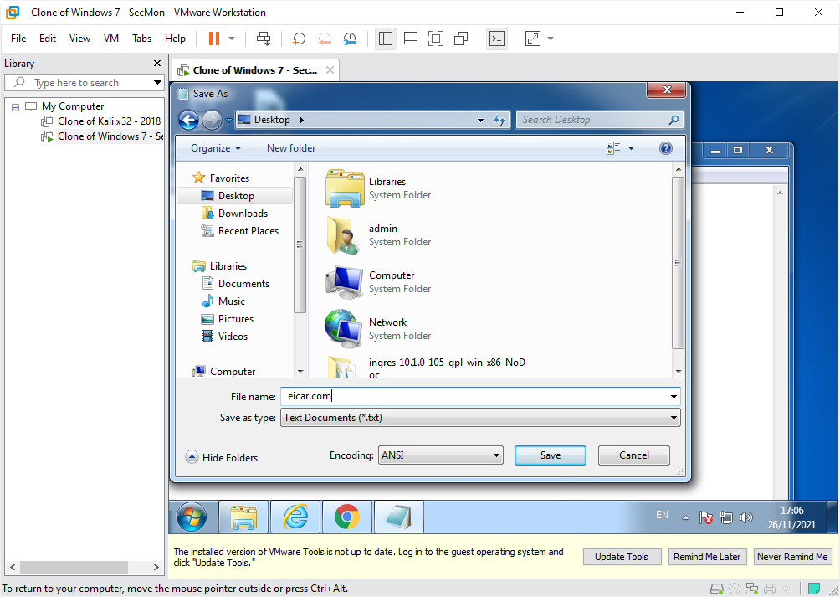

Eicar screenshot(s) & observations:

* Open a text editor such as Notepad.
* Copy the following string into the new file: X5O!P%@AP[4\PZX54(P^)7CC)7}$EICAR-STANDARD-ANTIVIRUS-TEST-FILE!$H+H*. Save the file aseicar.com.

Then file doesn’t open

# TASK 9:

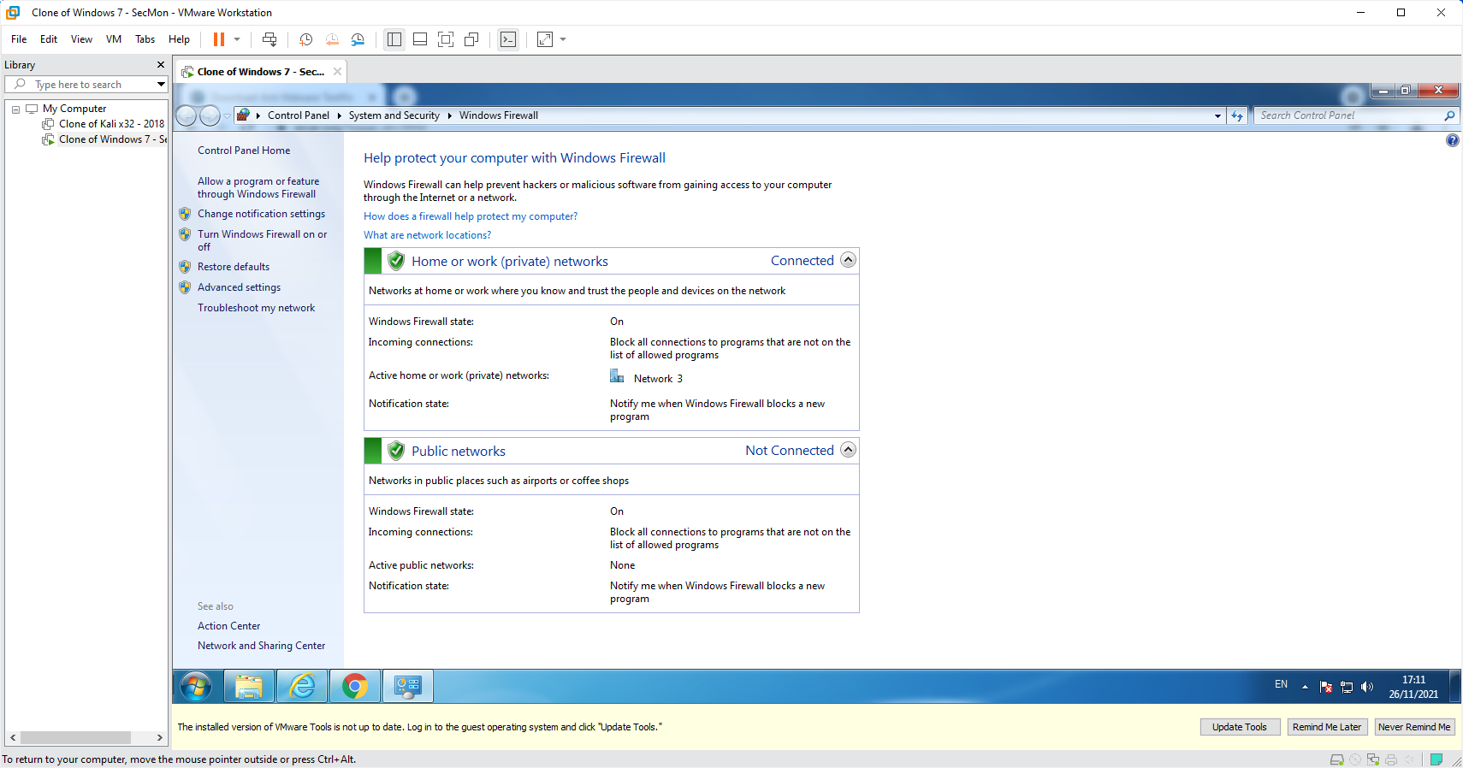

Screenshot(s) of Windows Firewall & observations:

Windows firewall status was on for all the profiles.

# TASK 10:

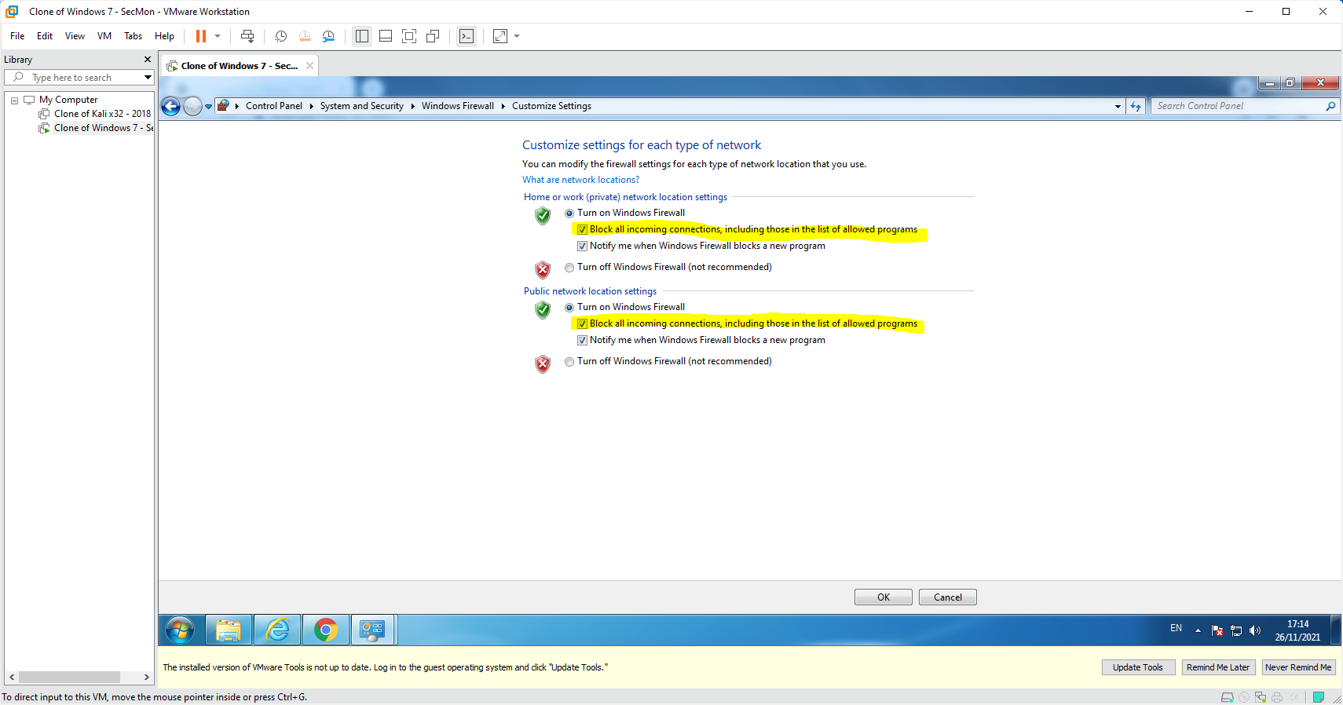

Screenshot(s) of firewall rule & observations:

By creating rule for all outgoing http trsffic it blocked all the outgoing http .

# TASK 11:

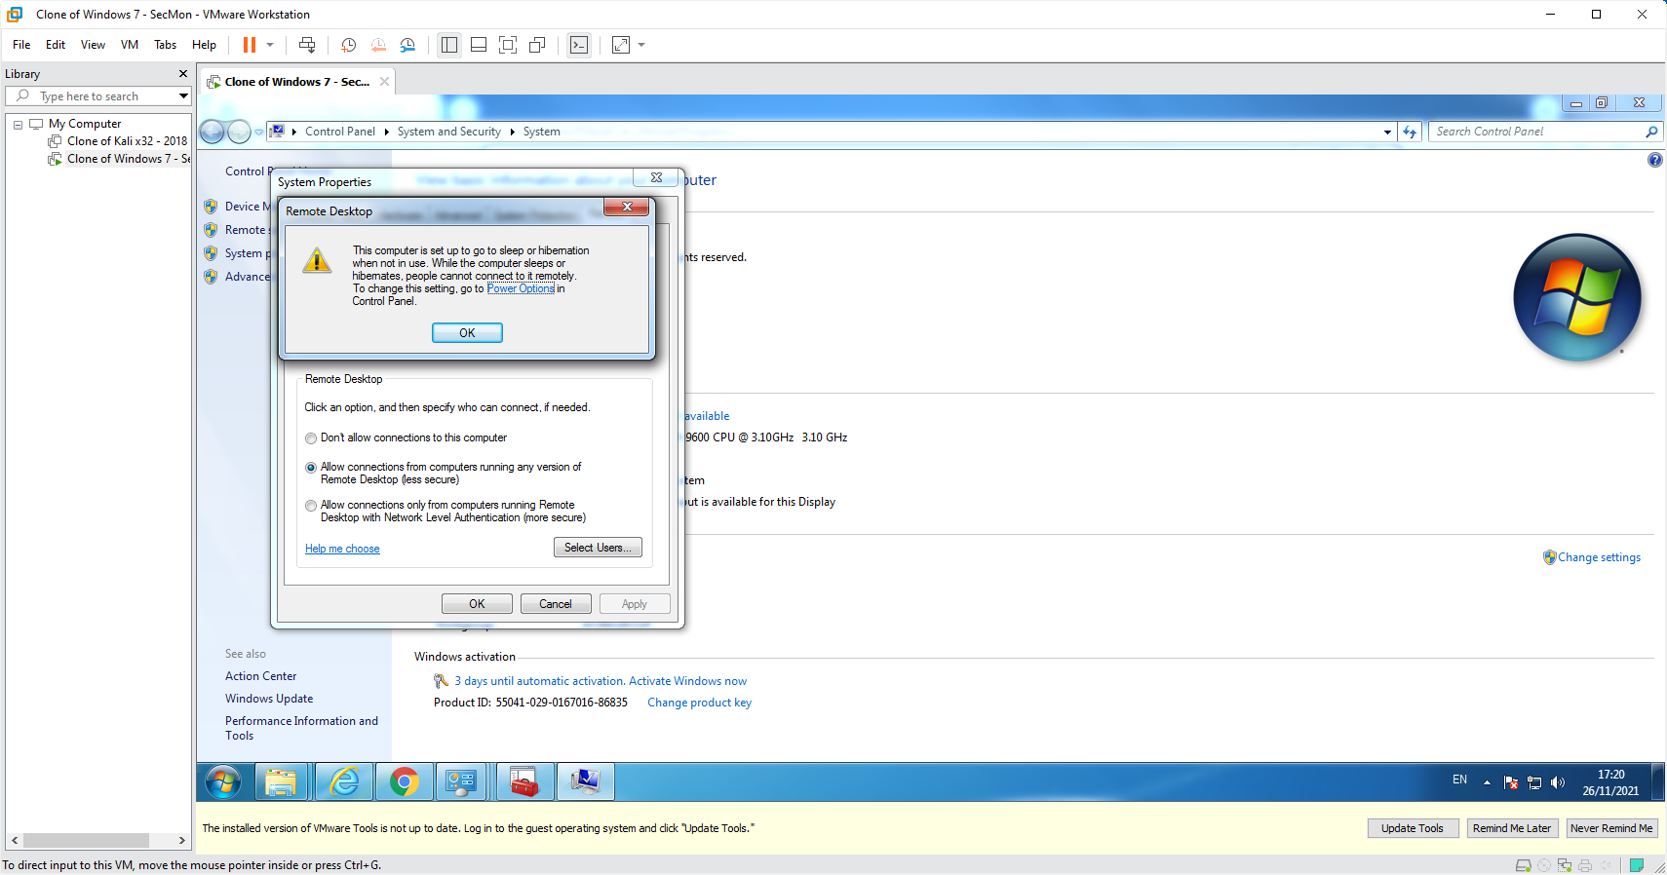

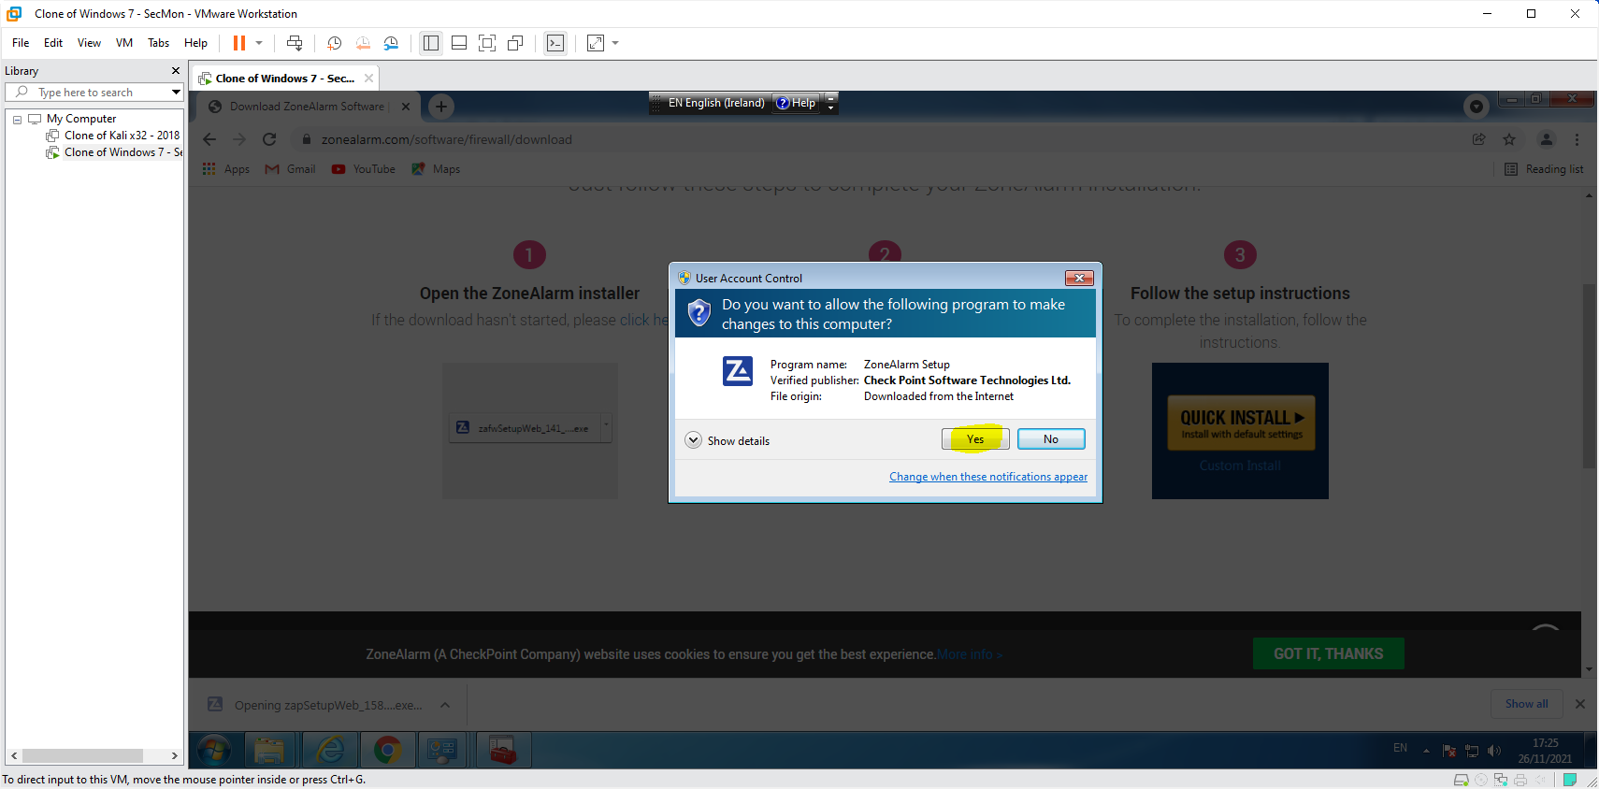

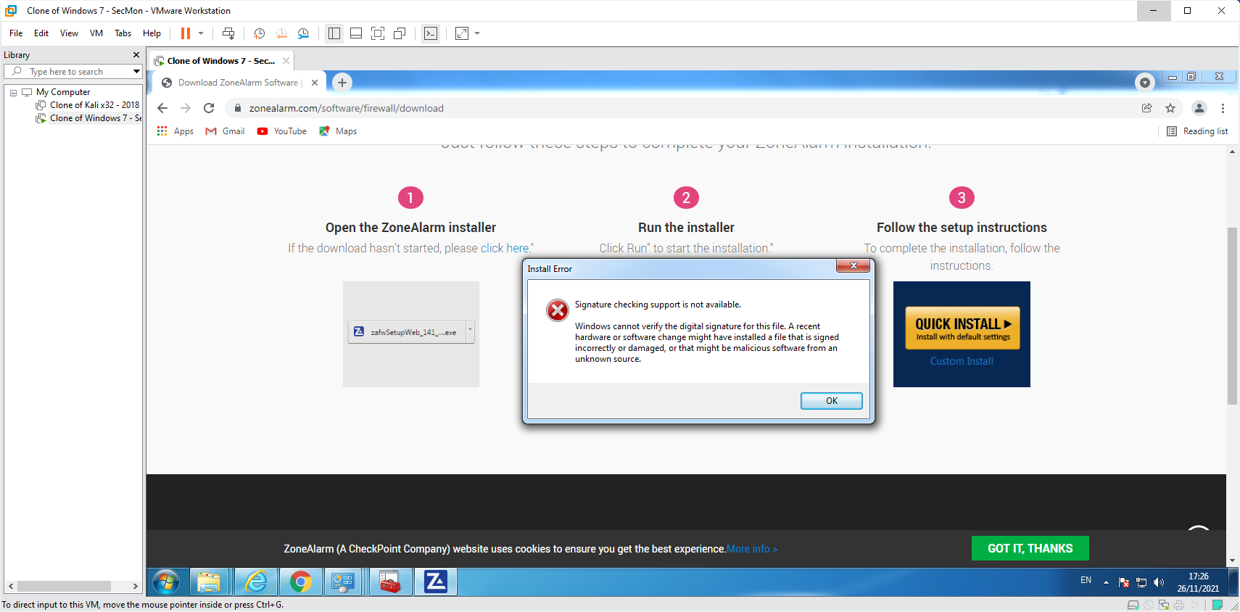

Screenshot(s) of ZoneAlarm & observations:

For zonealarm I got an error that signature checking support is not availabe

# TASK 12:

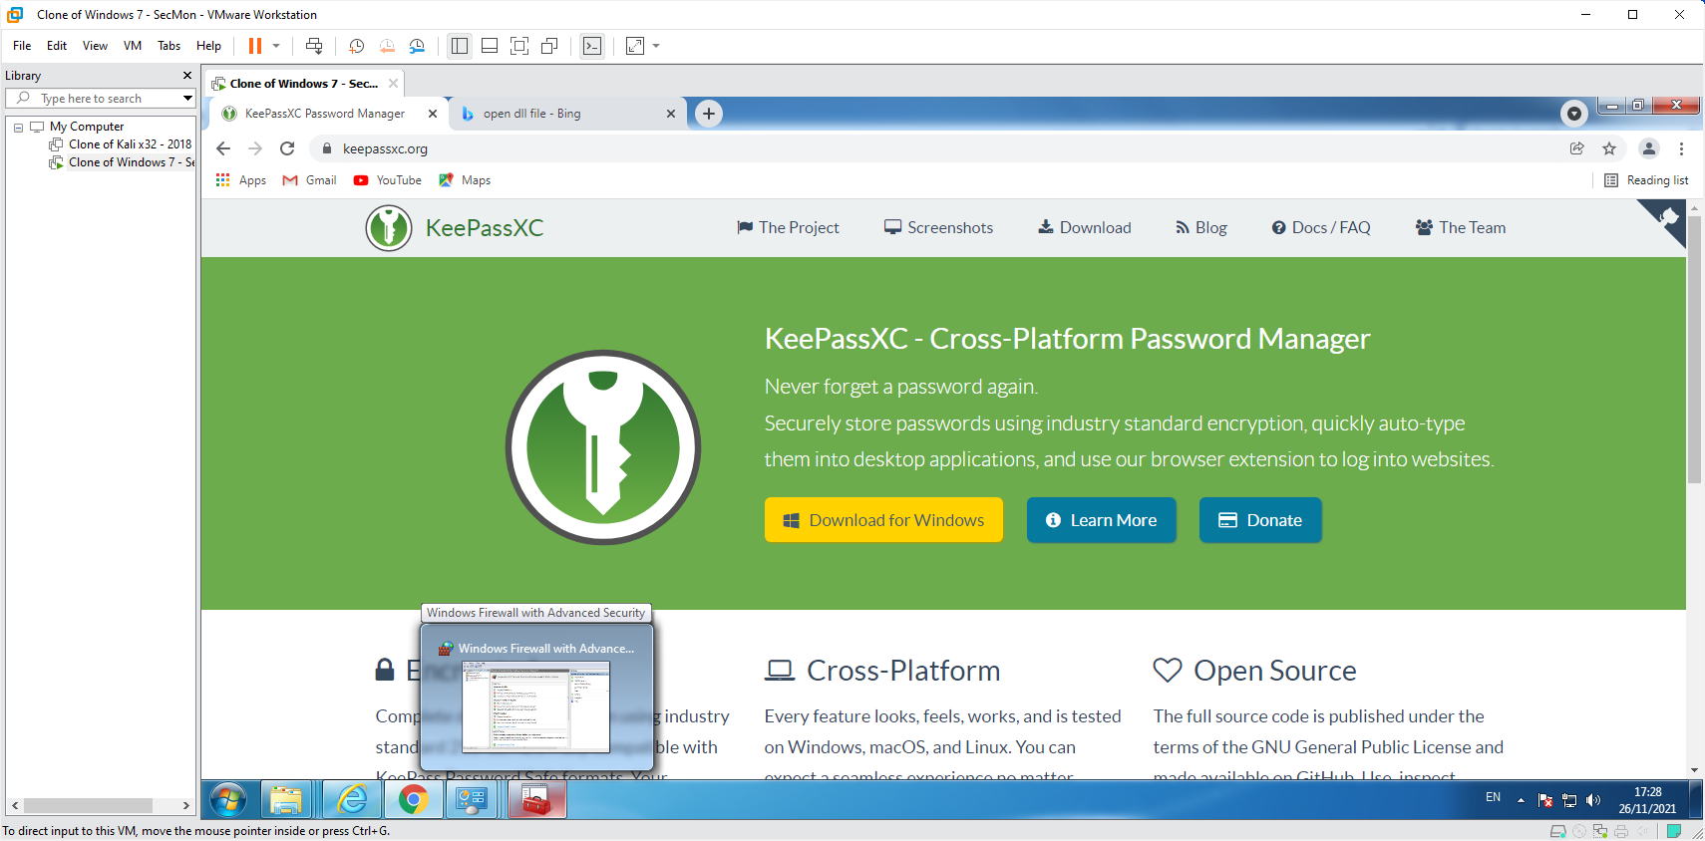

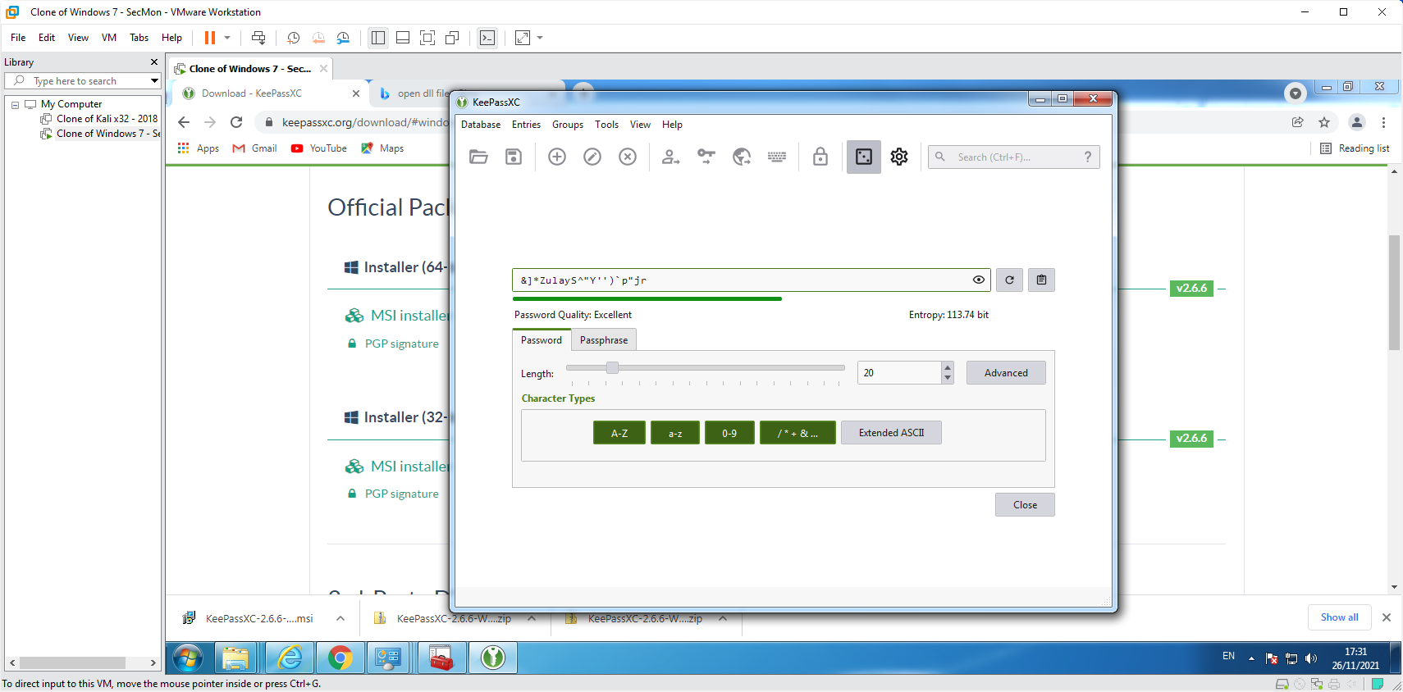

Screenshot(s) of KeePassX & observations:

KeePassX installed and tested successfully.

# 

# TASK 13:

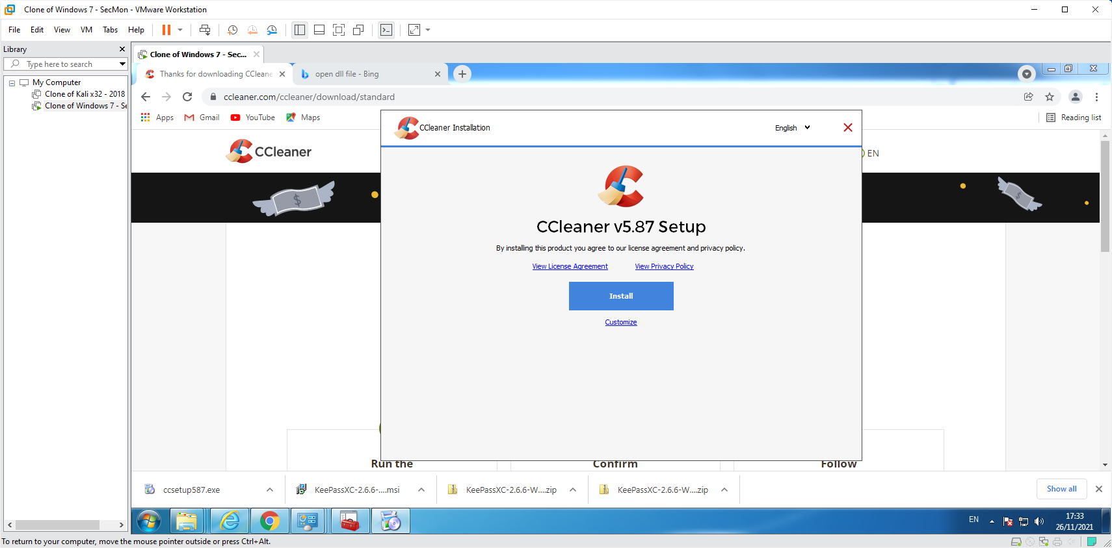

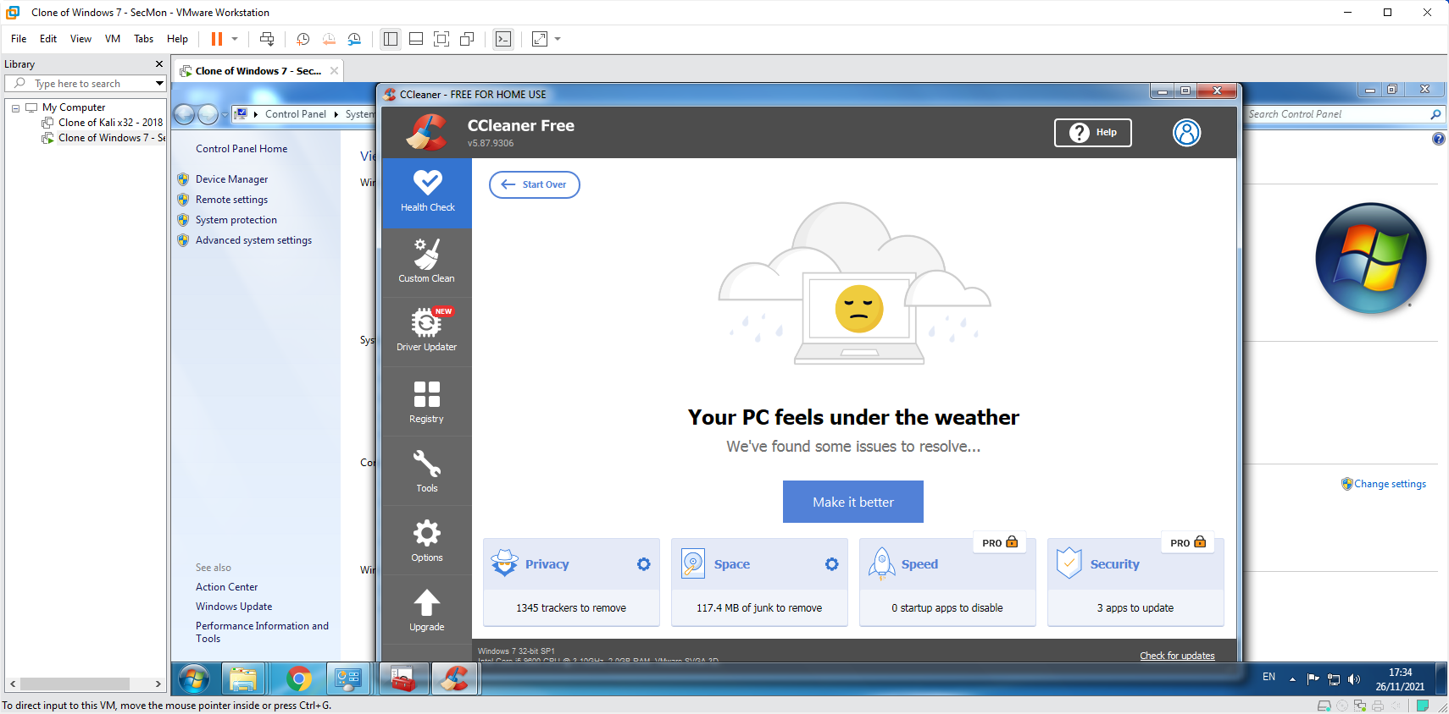

Screenshot(s) of cCleaner & observations:

cCleaner installed and tested successfully.

# PART 2

# TASK 1:

WebofTrust screenshot(s) & observations:

WebofTrust web extension added successfully.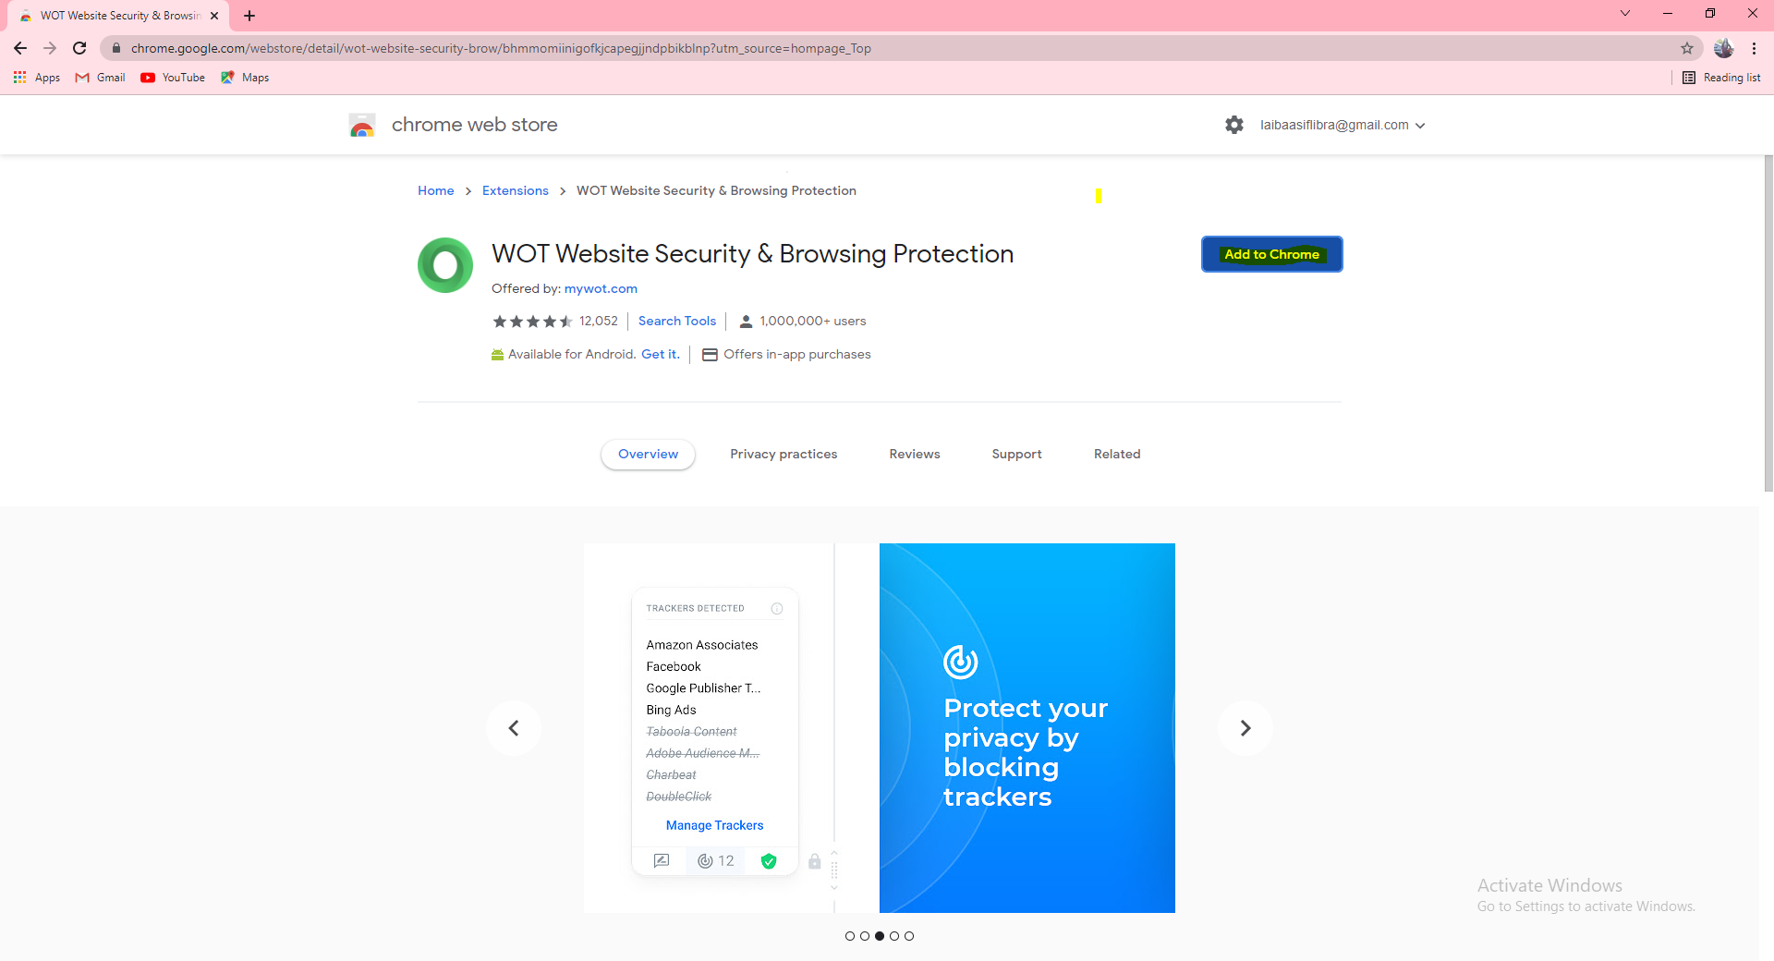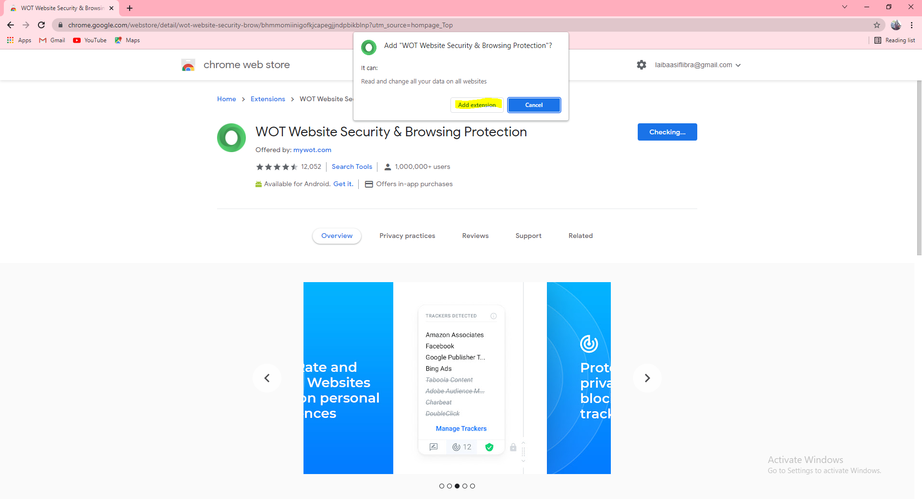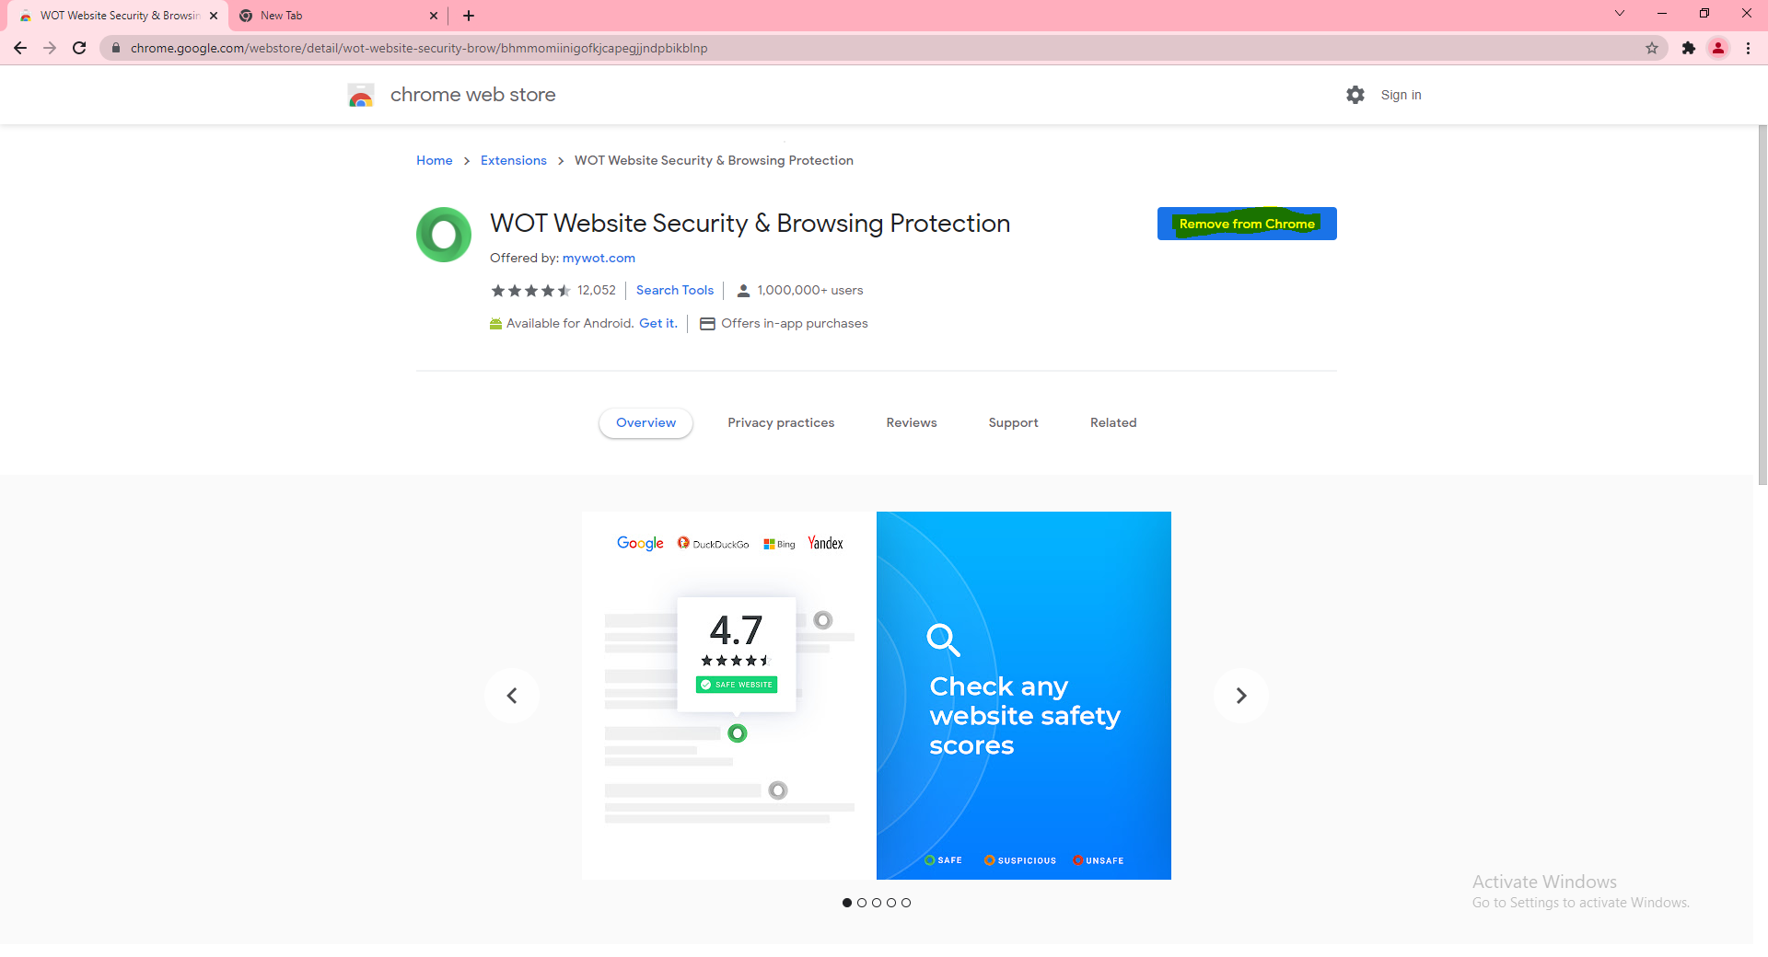

# TASK 2:

ScriptSafe screenshot(s) & observations:

ScriptSafe web extension added successfully.

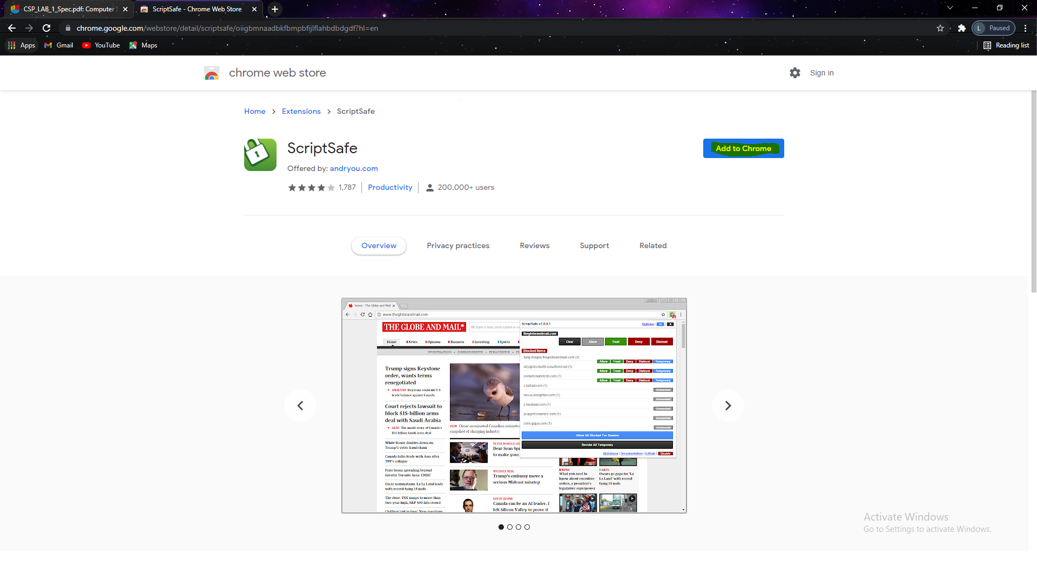

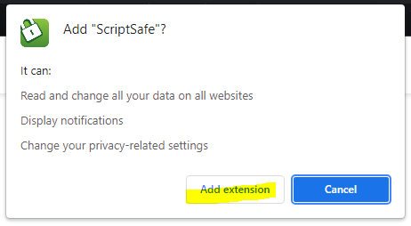

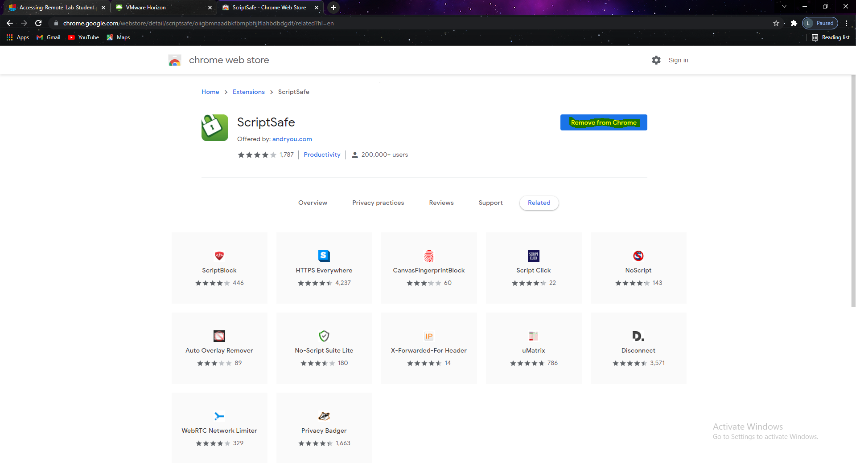

# TASK 3:

AdBlockPlus screenshot(s) & observations:

AdBlockPlus web extension added successfully 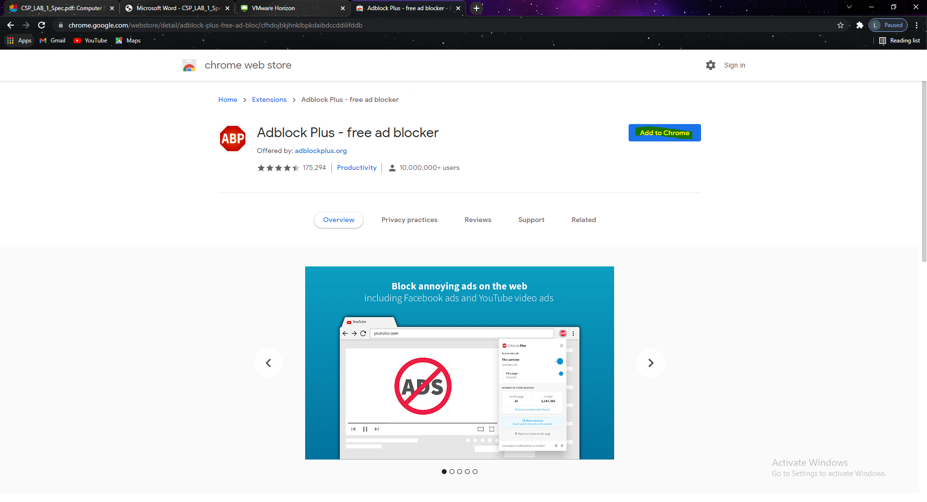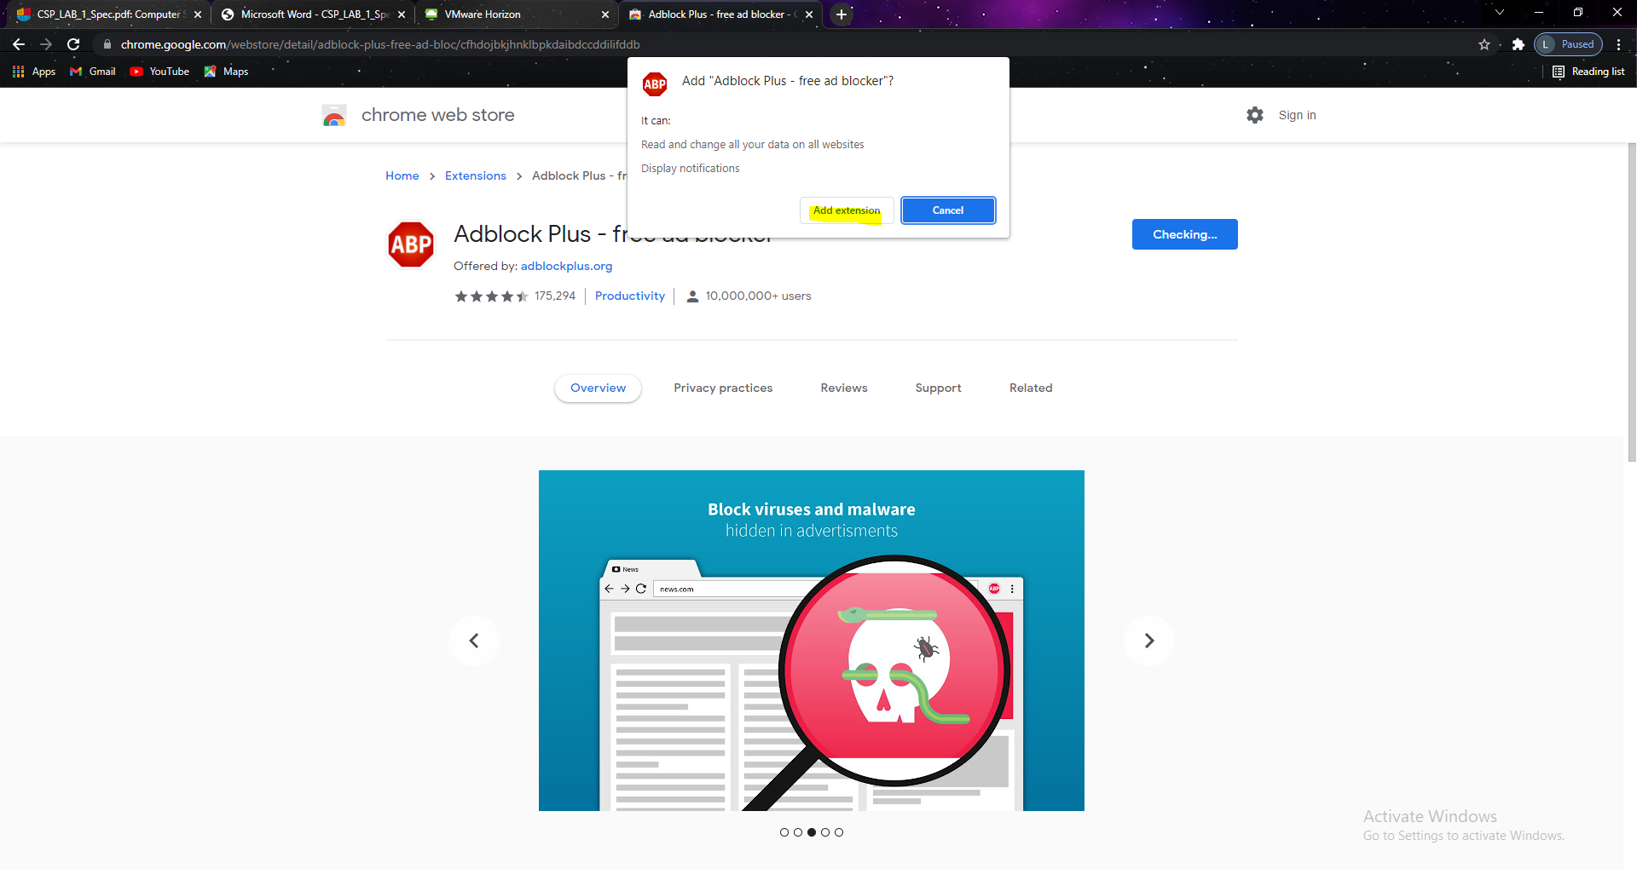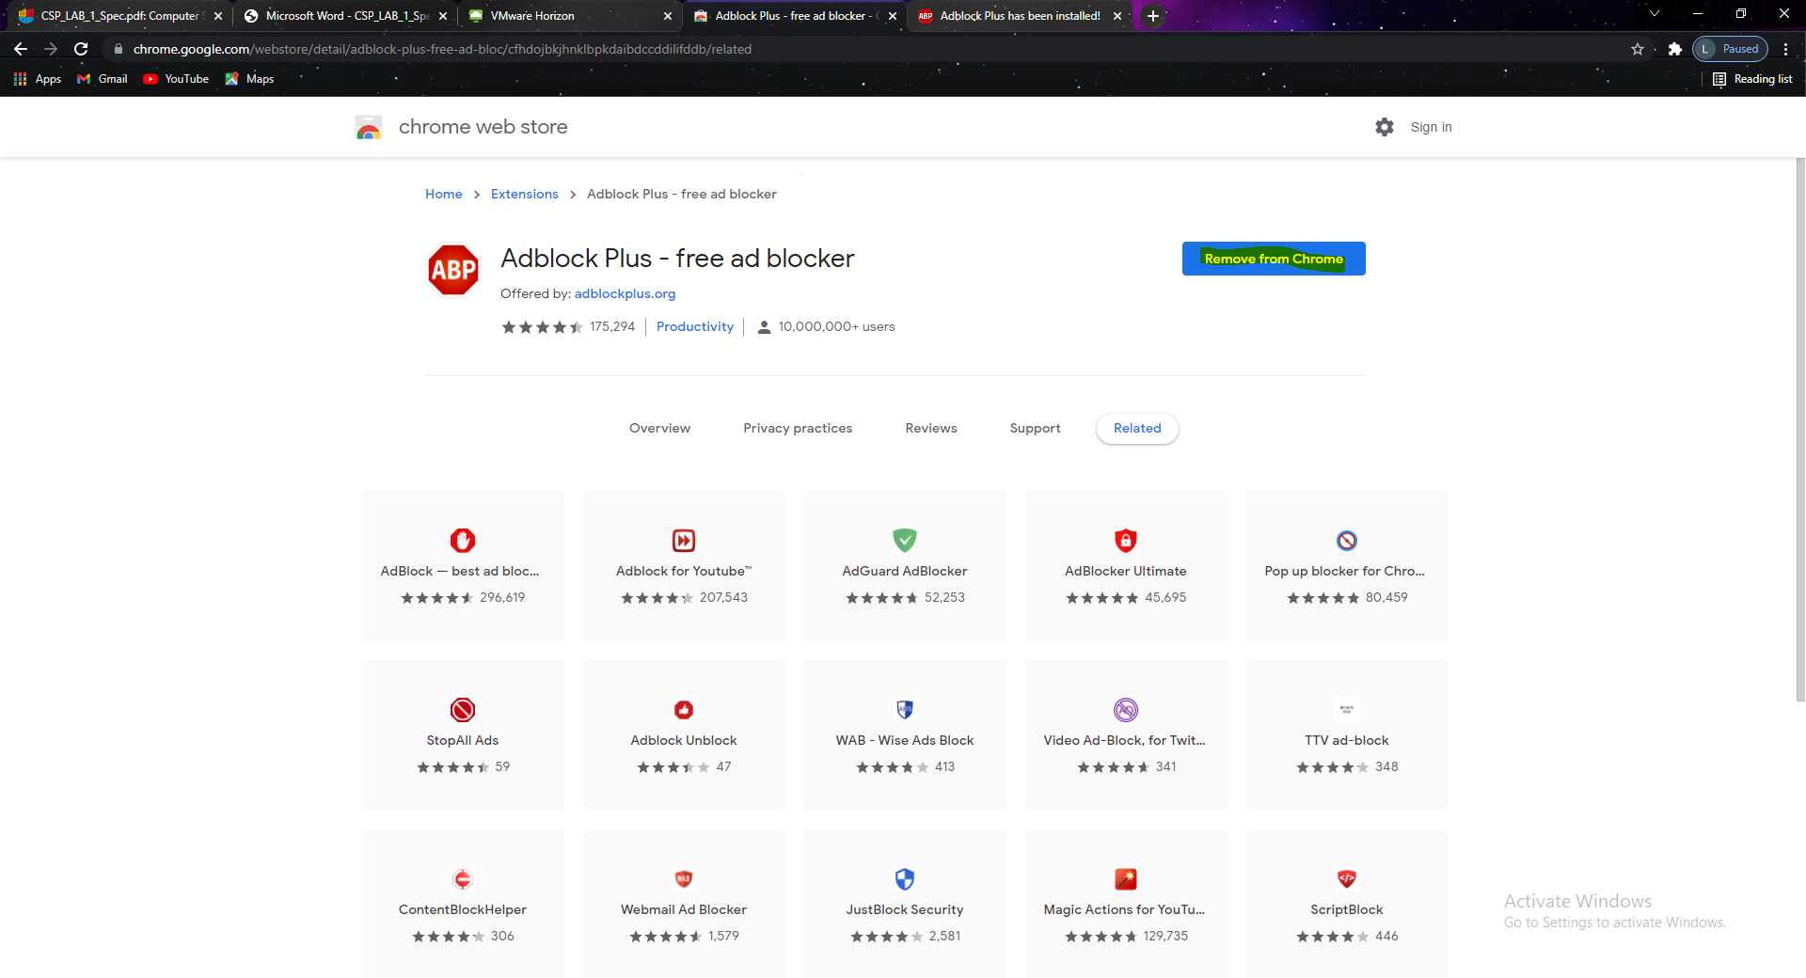

# TASK 4:

Ghostery screenshot(s) & observations:

Ghostery web extension added successfully

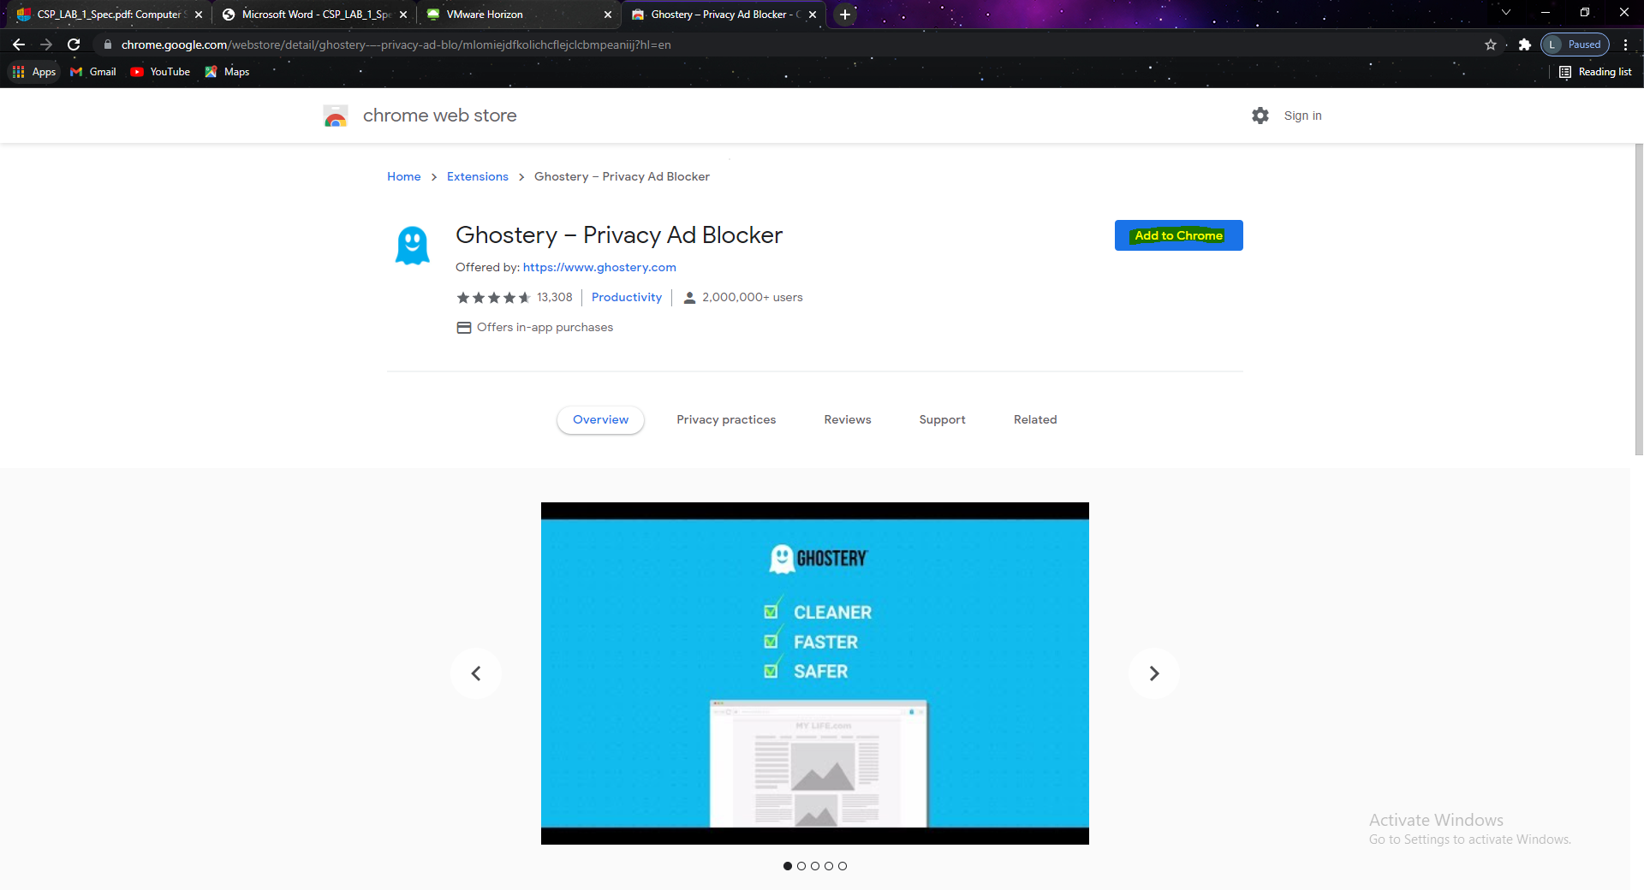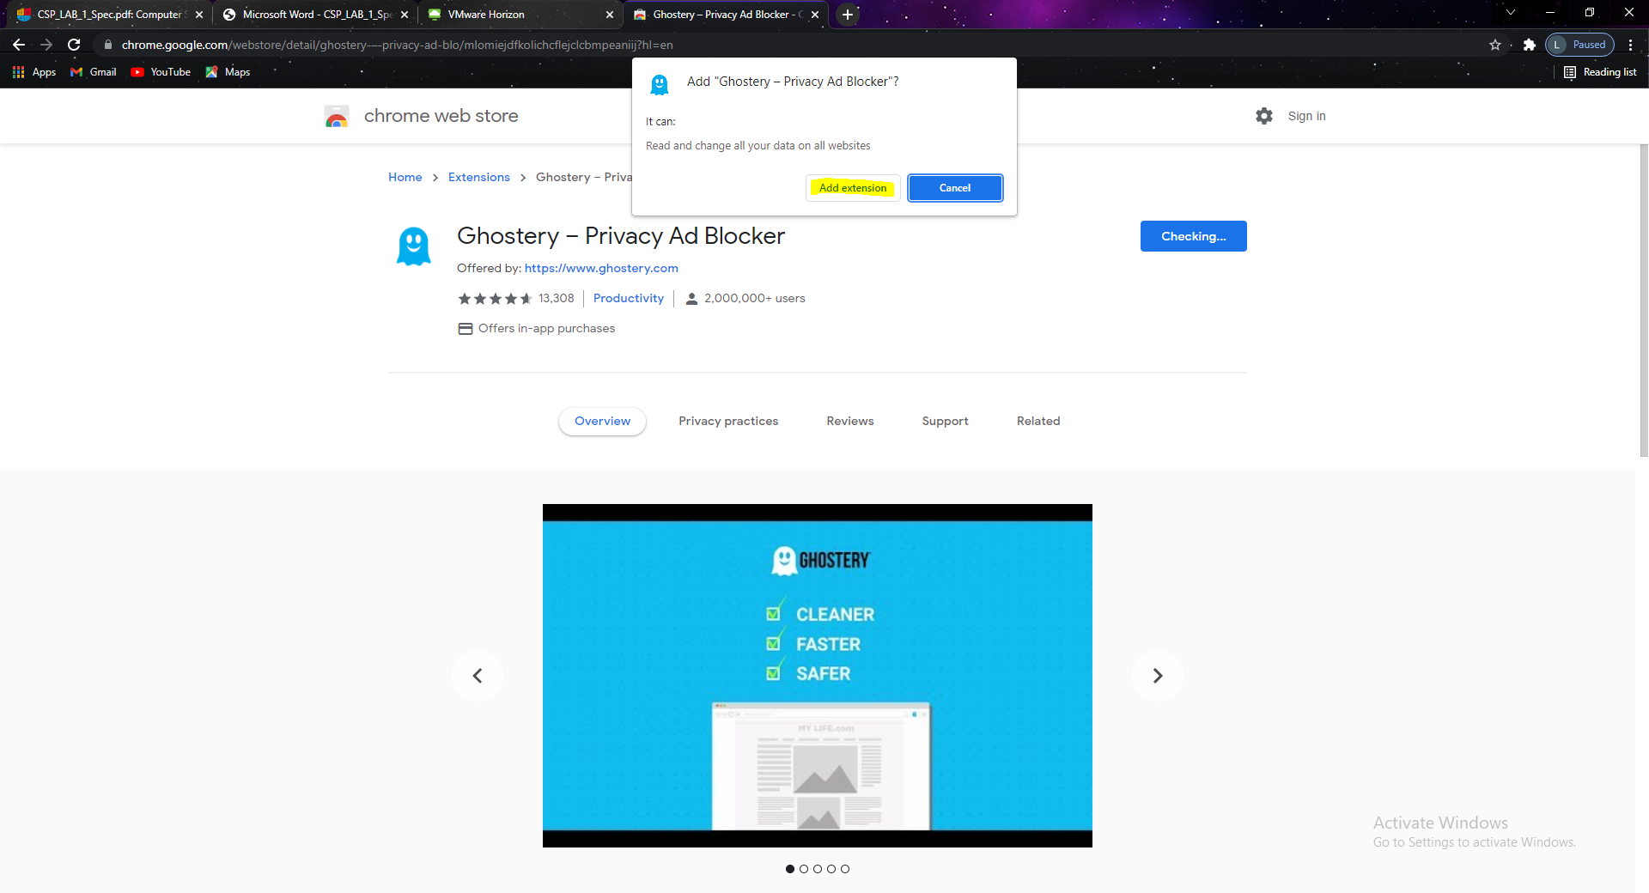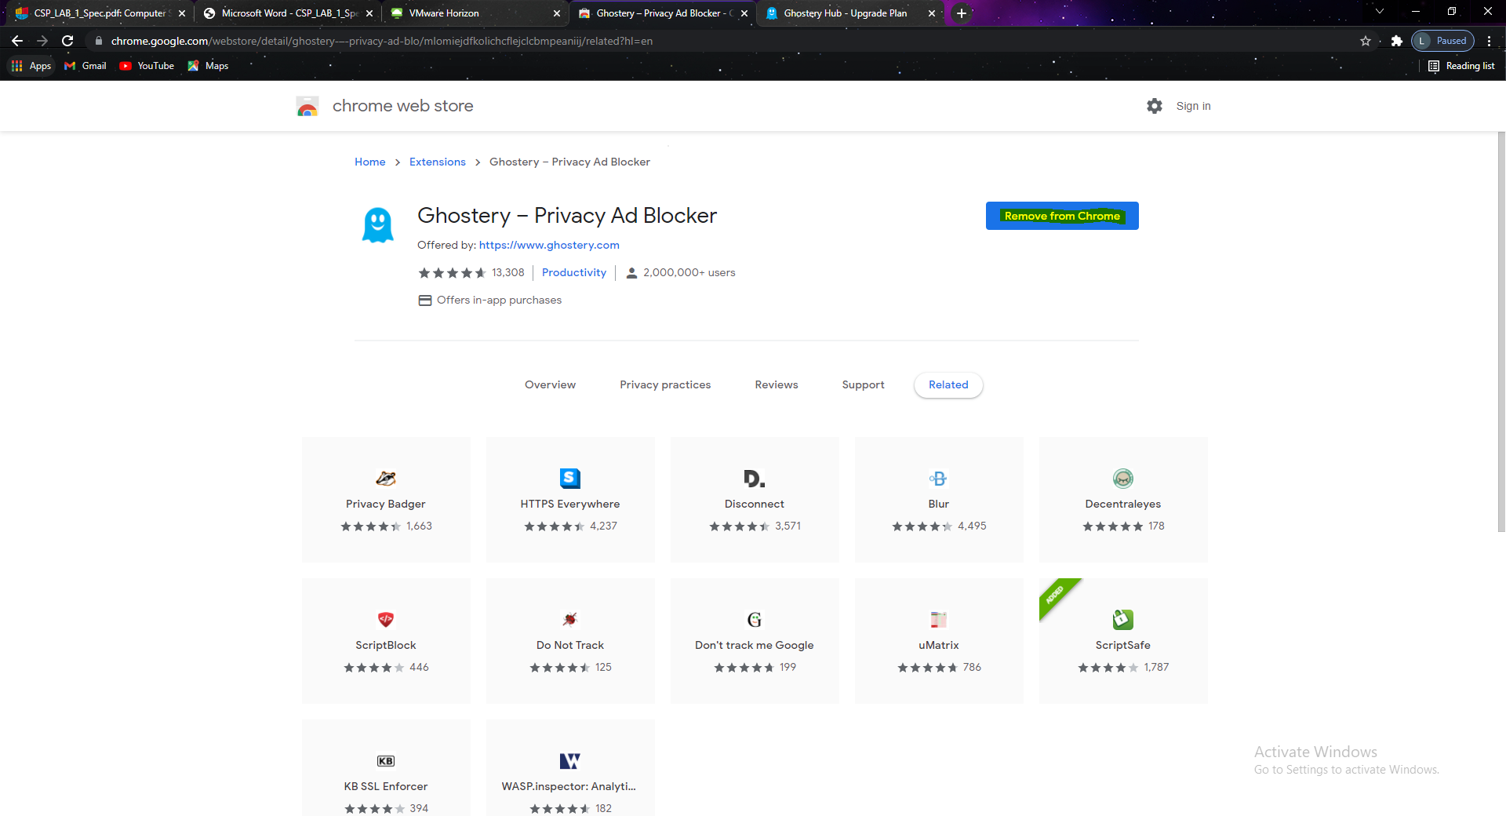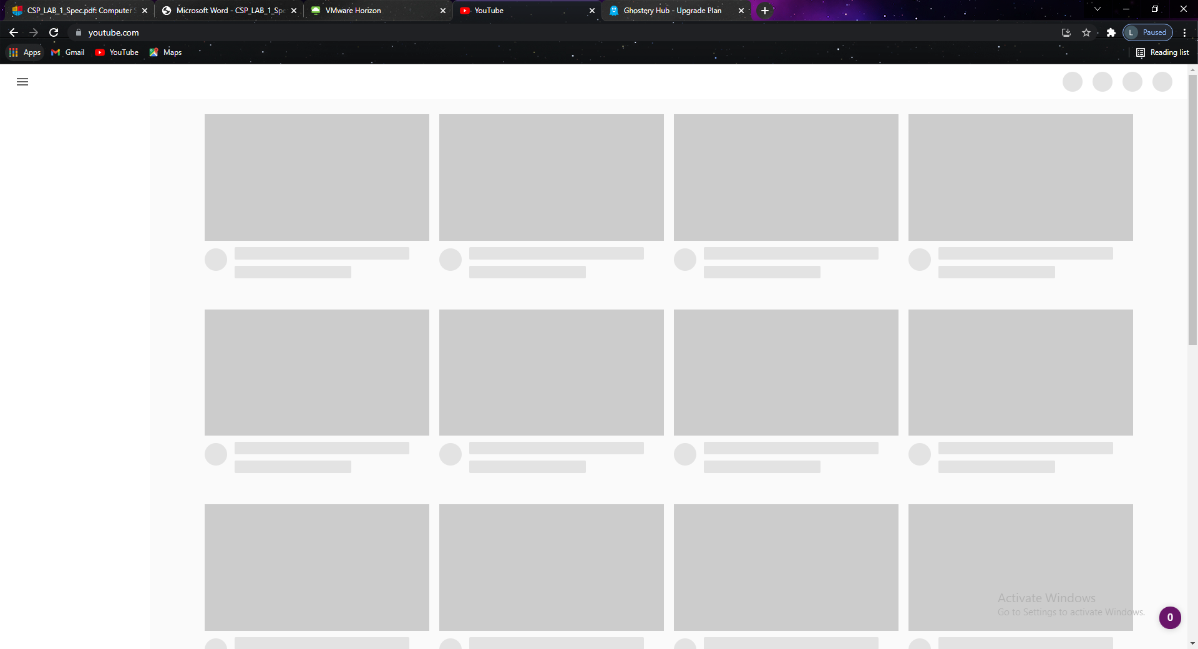

By installing these extensions the youtube doesn’t work.

# Conclusion

Summarise what you have learned in the lab. This is a significant part of completing lab work.

1. How to use Vm,  start a virtual Windows 7 virtual machine.
2. How Update this computer's operating system with the most recent patches.
3. Password-protect the Administration account.
4. In the operating system, create a non-privileged account.
5. Install and test two different antivirus programs.
6. Examine the Windows 7 Firewall's settings.
7. Make changes to the Windows 7 Firewall settings and test them.
8. Third-party firewall software should be installed and tested.
9. Install and try the CCleaner PC maintenance package.
10. Install the KeepassX password manager on your computer.
11. Install and test a variety of browser extensions to help you stay secure while browsing the web.